Extra study pages for final exam Spring 2012
Answer the questions in sentences.
- What are you wearing today?
____________________________________________________________________________________
- In what year did the Korean War end?
____________________________________________________________________________________
- What time do you usually get up?
____________________________________________________________________________________
- When is your final exam?
____________________________________________________________________________________
Fill in the blanks with the correct words.
1. Smith is a very neat person. He takes a shower ______________ a day, in the morning
and at night.
2. Brian ______________ takes a nap in the afternoon after lunch.
3. Ken doesn’t like to cook. He eats out for dinner almost ____________.
4. Allison ____________ wears skirts. She always wears jeans or shorts.
5. Pam goes shopping with her friends two ________________ a month.
6. Pete wants to keep in good shape. He works out every __________________.
twice everyday weeknight never always times
Make sentences using the words given in the box.
always often never rarely usually sometimes once a year(month) every Saturday twice a week every weeknight every other Wednesday twice a day
1. drink coffee > I rarely drink coffee.
2. exercise > ____________________________________________________________
3. go to an amusement park > _____________________________________________
4. eat out for dinner > _______________________________________________________
5. travel abroad > ____________________________________________________________
6. write e-mails > ____________________________________________________________
7. stay up late on Saturday night > _________________________________________________
8. go shopping > _____________________________________________________________

Complete the short dialogues.
1. A: How often does David wash his car?
B: He __________ washes it. He just wipes it once a year.
2. A: How ________ does Philip play computer games?
B: He plays computer games twice a day.
3. A: Does Vanessa always go straight home after work?
B: No, she never goes home straight. She _________ goes out with friends.

Put the sentences in the correct order to complete the dialogues.
1. _____ I often eat out for dinner.
_____ No, I rarely eat out for dinner. How about you?
_____ How often do you eat out for dinner?
1 Do you often eat out for dinner?
_____ I eat out for dinner twice a week.

2. ____ Then when do you usually have coffee?
____ I usually have coffee in the afternoon.
1 Do you usually have coffee in the morning?
____ No, I never have coffee in the morning.
3. 1 Do you ever go swimming?
____ About twice a week.
____ I usually go to the Mega sports Center.
____ Yes, I do.
____ How often do you go swimming?
____ Where do you usually go swimming?

E. Make sentences using the words given to complete the interview.
Interviewer: So, Jessica. Here are some questions from the audience. Ready?
Jessica: Okay. I’m ready.
Interviewer: ① home / at / ever/ do / cook / you? _______________________________________
Jessica: Of course.
Interviewer: ② cook / you / how / do / often? _______________________________________
Jessica: ③ the/ on/ usually/ weekend/ cook/ I. _______________________________________
I love cooking, but I don’t have time on weekdays.
Interviewer: ④ you / in / morning / do / the / do / what / usually? ____________________________________________________________________________
Do you go jogging or something?
Jessica: I go to a yoga class at 6am every Monday, Wednesday, and Friday.
And ⑤ at / I / yoga / do / home / and / Tuesdays / on / Thursdays. ______________________________________________________________________________
Interviewer: Oh, you are a yoga fan.
What do you usually do when you don’t have anything on your schedule?
Jessica: Not much. ⑥ to / listen / music / sometimes / I and… what else… read books. ______________________________________________________________________________
⑦ go / out / rarely / I / though. I usually stay home. _______________________________________
Interviewer: Then do you ever see your friends?
Jessica: Well, yes, but only once a month.

Read the interview above and correct the incorrect information in the statements about Jessica.
1. She loves cooking. She usually cooks on weekdays.
2. She goes to a yoga class three times a day.
3. She always goes out when she doesn’t have anything on her schedule.
4. She meets her friends only once a year.

Make questions and then write your own answers.
1. use the Internet
􀃎 A: How often do you use the Internet?
B: I use the Internet two or three times a week.
2. play online games
􀃎 A: ___________________________________________________
B: ___________________________________________________
3. write an e-mail
􀃎 A: ___________________________________________________
B: ___________________________________________________
4. use search engines
􀃎 A: ___________________________________________________
B: ___________________________________________________
5. use the Internet banking
􀃎 A: ___________________________________________________
B: ___________________________________________________
6. download MP3 files
􀃎 A: ___________________________________________________
B: ___________________________________________________

Match the rooms with the items.
- sofa ____1. bathroom
- stove ____2. bedroom
- pillow ____3. kitchen
- fire place ____4. living room
- plate ____5. laundry room
- tub ____6. living room
- razor ____7. kitchen
- lawnmower ____8. bedroom
- dresser ____9. bathroom
- washing machine ____10. backyard
What are the items in each room?
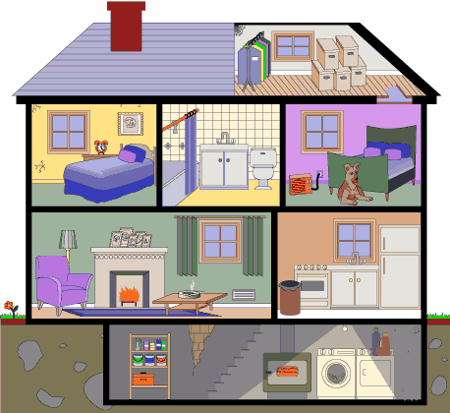
kitchen
a) ___________________
b) ___________________
c) ___________________
living room
a) ___________________
b) ___________________
c) ___________________
bedroom
a) ___________________
b) ___________________
c) ___________________
bathroom
a) ___________________
b) ___________________
c) ___________________
Answer the questions in sentences.
a) Are there any animals in the house? ________________________________________
b) How many are there? ________________________________________
c) Where is it? ________________________________________
d) Are there any windows in the house? ________________________________________
e) How many are there? ________________________________________
f) Where are they? ________________________________________
g) Are there any pink elephants in the basement? ________________________________ h) Where is the stove? _______________________________________________________
i) Where is the floor lamp? ___________________________________________________

16. Circle the category that best suits each group of words. ( /5)
- cheap, expensive, too much, reasonable
a) size b) style c) price d) material
- large, small, medium, huge, tiny
a) material b) size c) price d) style

- wool, silk, fabric, leather
a) size b) style c) price d) material
- TV, couch, bookcase, coffee table, loveseat
a) material b) style c) living room d) bedroom
- Counter, stove, toaster, refrigerator
a) Bathroom b) Kitchen c) Chicken d) Bedroom
- square, round, rectangular, oval
a) size b) style c) shape d) material
- teal, midnight , burgundy, lemon, kaki
a) material b) style c) living room d) colour

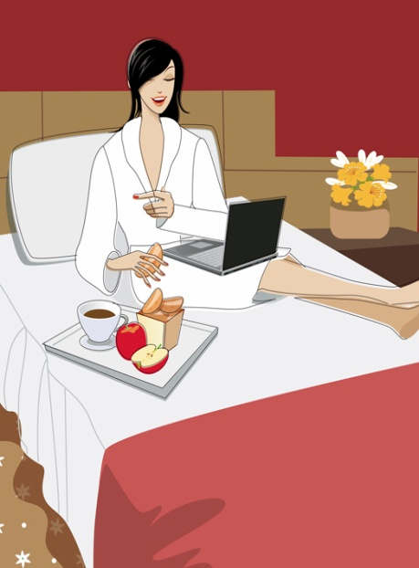

a) cup of coffee
flowers
sliced apple
box of bread
b) rug
lamp
armchair
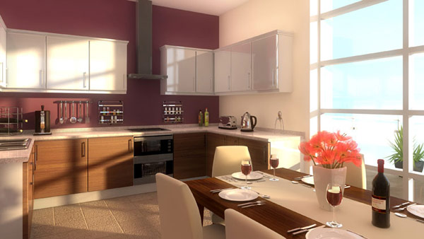

c) flowers
bottle of wine
toaster

Where are these items?
Give good descriptions using prepositions (on, under, in, behind, ...the right/left)
a) ________________________________________________________________________
________________________________________________________________________
________________________________________________________________________
________________________________________________________________________
b) _______________________________________________________________________
________________________________________________________________________
________________________________________________________________________
c) ________________________________________________________________________
________________________________________________________________________
_______________________________________________________________________
Write the name of the item or category.
- Write 9 colours
__________________, ____________________, _____________________
__________________, ____________________, _____________________
__________________, ____________________, _____________________
- Write 6 materials
__________________, ____________________, _____________________
__________________, ____________________, _____________________
- Write 3 patterns
__________________, ____________________, _____________________
- Write 5 shapes
__________________, ____________________, _____________________,
____________________, _____________________
- Write 3 sizes
__________________, ____________________, _____________________






What are you buying? Finish the sentences.
a: Hello, ___________ me.
b: Yes, may I _________ you?
a: _______ _________ is this purple and blue hat?
b: _________ is $68.00.
a: $68.00!!! _________ is too ________________!
_____ much are ________ blue hats on the counter?
b: _________ are $21.00 each.
a: That’s a good _________.
Who is he?
a: _________ is that?
b: Who?
a: _________ man next to Jackie.
b: The tall one with the _________ blonde _________?
a: No, the guy with _________ brown hair and ______________.
b: Him? He is _________ brother.

Circle and describe any person in these pictures.
What does he/she look like? (location, size, shape, colour, material, clothing, actions) _______________________________________________________
_________________________________________________________
_________________________________________________________
_________________________________________________________
_________________________________________________________
Read the descriptions of people’s personalities and write at least 2 words that match each description.
1. Victoria is an excellent worker. She also works really hard. She works almost 13 hours a
day. The reason that people like her is that she never shows off her success.
􀃎 _______________ __________________
2. Amy likes to meet new people. She also likes to invent new things. She is full of ideas.
􀃎 _______________ __________________
3. Tiffany likes to do things alone. She doesn’t like working in groups. She likes to help people. She always smiles at people. ________________ _________________

Complete the sentences with the appropriate words from the box.
1. People think Anna is optimistic, but she is very ______________.
2. Everyone says Evan is cold, but he is actually very _______________. He even has a good
sense of humor.
3. I thought Tylor was arrogant, but he is _____________. First impressions are not always right.
4. Everyone thinks Julie is very ______________, but she is outgoing.
5. My boss thinks that Amanda is ________________, but I can’t agree with her. Amanda is
actually very ___________. I’ve never seen her working.
6. Shane thought Crystal was _____________, but she is quiet.
lazy pessimistic hardworking friendly
reserved modest talkative sincere adventurous shy active outgoing

Fill in the blanks with appropriate words.
1. Cathy ________ blue eyes.
She has ________, straight, blond hair.
She is _______ her early twenties.
She ________ very kind and easygoing.
She ________ a lot of friends.

2. Alex _________ 45 years old.
He __________ 74 kg
and his ___________ is 173 cm.
He looks a bit __________.
He __________ short, _________ hair.
He ________ a high school math teacher.
He __________ generous and optimistic. Students like him.
Describe your best friend. Include his/her appearance and personality.
___________________________________________________________________
___________________________________________________________________
___________________________________________________________________
___________________________________________________________________
___________________________________________________________________
___________________________________________________________________

Read the conversation and check whether the following statements are
true (T) or false (F).

Morgan: Hi, Lisa. This is Morgan.
Lisa: Oh, hi.
Morgan: What are you doing?
Lisa: I’m just having a day off.
Morgan: Oh, good!
Are you reading books in bed as usual?
Lisa: No, as you suggested,
I’m trying new things today. I’m going to play tennis.
Morgan: Really?! That’s nice. It’s good to read books at home, but you need some exercise, too.
Lisa: Yeah, now I agree with you. How about you?
Morgan: Well, I just got out of a job interview.
Lisa: How did it go?
Morgan: Well… I don’t think I will get the job. I was so nervous. I couldn’t say a word.
Can you believe it?
Lisa: No, I can’t.
Morgan: Can you imagine me wearing a black suit and high heels?
I feel so uncomfortable today. It’s just not me.

T or F
1. Morgan is going to take a job interview soon.
2. Lisa is not outgoing.
3. Morgan is very active and energetic.
4. Morgan does not like to wear a formal suit.
5. Lisa usually plays tennis when she’s taking a day off.

Match the following titles with their appropriate genres.

1. Wheel of Furtune
2. Star Wars
3. Kung Fu Panda
4. Mission Impossible
5. FRIENDS
6. Indiana Jones
7. Oprah Winfrey Show
8. American Psycho
9. Bridget Jones’s Diary
▪ ▪
▪ ▪
▪ ▪
▪ ▪
▪ ▪
▪ ▪
▪ ▪
▪ ▪
▪ ▪
a. Romantic comedy
b. Animation
c. Action movie
d. Horror movie
e. Quiz show
f. Talk show
g. Sitcom
h. Sci-fi
i. Adventure movie

What is one more genre? ________________________________________

Fill in the blanks with the appropriate expressions. Then write 5 things you like and dislike under each category.
I really like it. I don’t like it. I love it. I hate it.
1. 2. 3. 4.
_____________ ___________ ____________ ___________
Cockroaches

Complete the sentences using the pictures below.
1. 2. 3. 4. 5.
6. 7. 8. 9.

1. I like ________________________________________
2. Sarah likes ________________________________________
3. We like ________________________________________
4. They like ________________________________________
5. Mike likes ________________________________________
6. Eric likes ________________________________________
7. Jenny likes ________________________________________
8. I like ________________________________________
9. My father likes ________________________________________

Put the sentences in order.

1. ___Yes, I do.
___What kind of music do you like?
1 Do you like music?
___I like pop music.

2. ____No, not really. I usually fall asleep.
____Do you like watching movies?
4 Yes, I really like it.
____Do you like driving then?

3.
2 I like to go to the theater on the weekend.
____What do you like to do on the weekend?
____How about you?
____Well, I like to go to mountain climbing.

4. ____Do you like flowers?
____I like tulips. How about you?
____I ike tulips, too. But, I love roses.
____Yes, I do.
3 Which flower do you like?

5. 4 He doesn’t like staying home.
____What does Gary like to do on the weekend?
____He likes to play soccer and basketball on the weekend.
____What doesn’t he like doing then?

6.
____But, I don’t like staying home.
1 Hi, I’m Robert.
____ I especially like to play soccer and basketball on the weekend.
____I love all sorts of sports

Fill in each blank with the appropriate words or phrases.
1.
A: What do you like to do on the weekend?
B: I like to _____________ shopping. How about you?
A: Well, I like to _____________ cards.

2.
A: What do you _________ to do on the
______________?
B: I like to go ___________.
_______ about _________?
A: Well, I like to go _______________ on the weekend.

3.
A: __________ do you like to do _______ the weekend?
B: I ________ to _____________ with my friends on the weekend.
How _______ you?
A: Well, I like to ____________________.

4. A: Do you like to eat out for dinner?
B: Yes, ___ ____. How about _____?
A: ________, I don’t. I ________ to cook for myself.
B: Do you ________ to _________ books on the weekend?
A: Yes, I do.

.

Fill in each blank with the appropriate name of the room.
yard
living room
kitchen
garage
bedroom
bathroom
basement

Look at the pictures below and complete the blanks.

1. Q: How many bedrooms are there in Joy’s apartment?
A: ______________________________________________________________
2. Q: What is in Joy’s living room?
A: _______________________________________________________
3. Q: Is there a desk in Joy’s apartment?
A: _________________________________________________________
4. Q: ________________________________________________________
A: There is one bathroom in Scott’s townhouse.
5. Q: ________________________________________________________
A: There is a refrigerator, a dining table, and four chairs.
6. Q: ________________________________________________________
A: No, there isn’t a desk in Scott’s townhouse.

Look at the picture below and check (V) whether the following statements
are True or False. Then correct the wrong sentences.
True False

1. There is a lamp stand in the living room.
2. There is a cat in the living room.
3. There aren’t two cushions on the couch.
4. A cell phone is on the table.
5. There is a treadmill in front of the window.
6. There isn’t a stereo in the living room.
7. There is a newspaper under the table.

Complete the puzzle and find the hidden word.
1. 2. 3.
4. 5. 6.

1. The pen is _________________________ the book.
2. The pen is _________________________ the book and the flower vase.
3. The pen is _________________________ the book.
4. The pen is _________________________ the book.
5. The pen is _________________________ the book.
6. The pen is _________________________ the book.
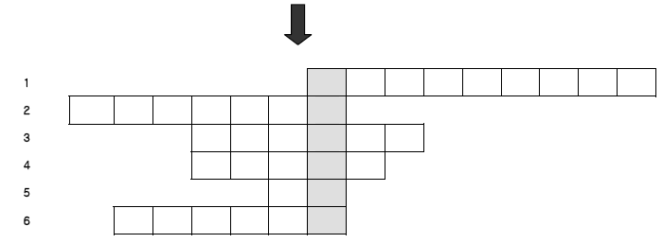
∴ The hidden word is _______________.

